Hope for blind as scientists find stem cell reservoir in human eye

Scientists at the University of Southampton have discovered stem cells in the human eye which can be transformed into light sensitive cells and potentially reverse blindness
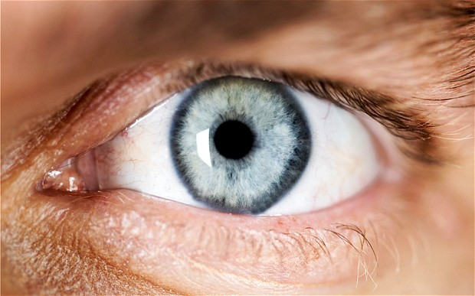
Scientists have discovered stem cells in the human eye which can be turned into photoreceptor cells and potentially reverse blindness
Hundreds of thousands of people who are registered blind have been offered new hope after scientists discovered special stem cells in the human eye which can be altered to pick up light.
Researchers at the University of Southampton have discovered a reservoir of stem cells in an area of the eye called the corneal limbus.
And they have proven that, in the right environment, they can be transformed into photo-receptor cells which react to light.
Scientists are hopeful that implanting the cultured stem cells in a damaged eye could reverse blindness.
It could offer a potential cure for the hundreds of thousands of people suffering macular degeneration or retinitis pigmentosa, which are both caused by the loss of photo-receptor cells in the eye.
And researchers were amazed to find that the cells even existed in the eyes of a 97-year-old, opening up the possibility that the treatment could work for the elderly.
“These cells are readily accessible, and they have surprising plasticity, which makes them an attractive cell resource for future therapies,” said Professor Andrew Lotery, of the University of Southampton and a Consultant Ophthalmologist at Southampton General Hospital led the study.
“This would help avoid complications with rejection or contamination because the cells taken from the eye would be returned to the same patient.
“More research is now needed to develop this approach before these cells are used in patients.”
The loss of photoreceptors cells causes irreversible blindness.
Age related macular degeneration (AMD), the leading cause of blindness in the developed world which affects around one in three people in the UK by age 75.
Around 513,000 people are in the late stage of AMD and that figure is set to rise by one-third over the next decade, totalling nearly 700,000 cases by 2020.
Almost two million people in the UK are living with sight loss, approximately one person in 30.
It is predicted that by 2020 the number of people with sight loss will rise to over 2,250,000. By 2050, the number of people with sight loss in the UK will double to nearly four million.
There is currently no treatment for blindness caused by the loss of photo-receptors.
So far scientists have only shown that the concept works in the lab and are yet to implant them in a human patient. But they are hopeful that the cells could be taken from a patient, grown in the lab and transplanted back into the eye. Clinical trials should begin within five years.
Charities are optimistic that it could herald a brighter future for people with sight loss.
Clara Eaglen, RNIB Eye Health Campaigns Manager, said: "At RNIB we talk to people everyday who tell us about the huge impact that losing their sight has on daily life, so this is very interesting research.
"The study shows that you can grow stem cells and make them act like light sensitive cells, a big step forward in helping patients with conditions such as age-related macular degeneration where damage has occurred to the light sensitive cells.
"These cells can then be taken from a patient, changed, and replaced - reducing the risk of rejection which is exciting.
"We are hopeful that stem cell technology will significantly change the way in which people with sight loss are treated over the next decade."

